ActionAid’s Ten Principles of Feminist Leadership

Our transformative vision of a just world free from poverty, oppression and patriarchy requires transformative feminist leaders: leaders who enable others to lead, building power with them instead of over them.  To develop this approach, we have adopted a set of feminist leadership principles.

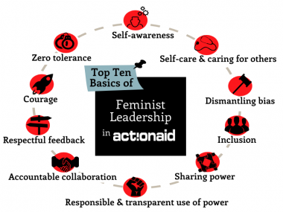

**1. Self-awareness**

We will keep our egos in check, so that we can lead with empathy and open minds. In order to do this, we will work towards accepting our vulnerabilities, as well as recognising and valuing our strengths and those of others.

**2. Self-care and caring for others**

We will take care of our emotional and physical well-being, in order to renew our inner sources of inspiration and compassion so we can continue to give of our best. We encourage and support others to do the same, actively working towards a more flexible and supportive work environment, particularly for those with caring responsibilities.

**3. Dismantling bias**

We recognise that society gives us (and others) certain advantages that are not asked for or earned (for example, based on gender, class, race, caste, ability, sexual orientation, education or other factors). We will help to uncover and challenge these forms of discrimination in our day to day workplace practices and policies. We will be aware of how our own privileges can make others feel disempowered or inferior, as well as how we react to others' privilege, and deliberately change our behaviour to treat everyone as equals.

**4. Inclusion**

We will create ways for everyone to be equally heard, respected and successful. We will challenge ourselves to build diverse and inclusive teams and to recognize and respond to different barriers to participation.



**5. Sharing power**

We accept that the ultimate test of leadership is the spaces we create for others to lead. We will work together to establish shared goals and will trust and empower colleagues to share leadership in reaching those goals. Likewise, we will trust and support those in positions of authority to guide us in the best interests of our mission.

**6. Responsible and transparent use of power**

We will be clear, timely and transparent in making decisions, with appropriate consultation and in the interests of our mission. If involved in allocating resources and choosing partners, we will ensure these choices promote ActionAid’s values and aspirations. we will communicate decisions, and the reasons for them, openly.

**7. Accountable Collaboration**

We will ensure that our goals are clearly defined and mutually owned and hold ourselves strongly accountable for our individual and collective efforts to achieve them. We will measure our achievements by the contributions we have made to team success. We will recognise and value successful collaboration, while addressing poor performance fairly but decisively.

**8. Respectful Feedback**

We will seek, give and value constructive feedback as an opportunity for two-way learning. We won’t wait for formal reviews – instead we practice continuous feedback, to all those we work with. We will work to resolve conflict through active listening, timely intervention and promoting non-violent and respectful communication and behaviour.

**9. Courage**

We will constantly aim for transformative change, seeking out new ideas and learning from mistakes rather than fearing failure, and empowering those we work with to do the same. When we encounter defeatism or cynicism, we will strive to restore belief in our goals; where there is competition or insecurity over status and turf, we will build trust; and where we find complacency or mediocrity we will help to renew passion and creativity to excel in our mission.

**10. Zero Tolerance**

We will call out any form of discrimination and abuse of power that we witness or experience in the workplace, and safely enable and support those around us to do the same. We will ensure our own conduct is free from any form of harassment, exploitation and abuse.